UNIVERSITY OF NAIROBI

COLLEGE OF BIOLOGICAL AND PHYSICAL SCIENCES

DEPARTMENT OF CHEMISTRY

DETERMINATION OF IMMUNE BOOSTING TRACE ELEMENTS IN SELECTED FOOD GRAINS

BY

WAMBUI PERIS NYAGUTHIE

I64/85992/2017

A Project Submitted in Partial Fulfillment of the Requirement for the Degree of Bachelor of Science in Chemistry

2021

DECLARATION
I declare that this project is the original idea of the author and has not been submitted elsewhere for research, award of a degree or publication. Other people’s work used, has been properly acknowledged.

Signature-------------------------------------------- Date: 11/06/2021
Peris WAMBUI
(I64/85992/2017)
This project report has been submitted with our approval as university supervisors

Signature Signature
Date: 11/06/2021 Date: 12/06/2021

DR. JOYCE KITHURE DR. DEBORAH. A. ABONG’O
Department of Chemistry Department of Chemistry University of Nairobi University of Nairobi

DEDICATION

I dedicate this project to World Scholarship Initiative (WSI) for their continuous support throughout my secondary and tertiary education. A special thanks to Tom, Katie and their families for bringing together a group of friends to see the support growing over the years. I also dedicate this to the Wanjohi’s family for guiding and supporting me whenever they could. Lastly, I dedicate this to St Paul’s community for the moral and spiritual guidance that kept me going even when things were getting tough and I felt like giving in or giving up. They were always there to guide me through. Thank you all and Blessings upon you!

ACKNOWLEDGEMENT

This far in my life, it is God! Thank you almighty for giving me strength to push on even when the ground was not favorable at all. Thank you for your mercies, faithfulness, kindness, generosity and mostly for your graces in my life.

I thank my mother and siblings for their support in my education and for the sacrifices they made for me to go through with my education.

To my supervisors, Dr Joyce G. N. Kithure and Dr Deborah A. Abong’o, thank you for accepting to be my supervisors and always being ready to help, guide and keeping us on track to do and submit our work in time.

I would like to appreciate everyone who contributed to the success of this project and my friends who we always worked together in the laboratory and also our laboratory technicians, Dr Rop, Mr Orangi and Mrs Alice.

I cannot forget to thank the University of Nairobi for providing an enabling environment for learning and gaining other skills.

ABSTRACT

The trace elements are essential in strengthening the immunity in our bodies to fight the infections which would otherwise compromise our health status. They have the power to fight even the diseases which have no cure such as cancer. The general objective of this study was to determine the concentrations of Nickel, Iron, Zinc, Copper, Magnesium and Manganese in selected milled food grains. The milled maize, millet and sorghum were obtained from the millers in Nairobi. Three samples of each milled food grain were digested using 65% HNO₃ and aqua regia and then analyzed using the Atomic Absorption Spectrometer (AAS). The study showed that the concentrations of the trace elements in the milled food grains were in the following order: Zn in: millet (0.0353±0.0162 mg/g) > maize (0.0206±0.0005 mg/g) > sorghum (0.0180±0.0011 mg/g); Fe in: sorghum (0.0675±0.0168 mg/g)> millet (0.0580±0.0103 mg/g)> maize (0.0273±0.0060 mg/g); Cu in: Sorghum (0.0434±0.0075mg/g) > millet(0.0322±0.0052 mg/g) > maize (0.0321±0.0060mg/g); Mn: sorghum (0.2154±0.0181 mg/g) > millet (0.1391±0.0143 mg/g) > maize (0.0716±0.0275 mg/g); Mg in: sorghum (0.3938±0.0015 mg/g)>millet(0.3852±0.0083mg/g) >maize (0.3845±0,0020 mg/g). Nickel was detectable only in maize (0.0014±0.0000 mg/g) but was below the detectable level in other food grains. The concentrations of Fe, Ni and Cu were within the stipulated levels of WHO and KEBS while Mn concentrations were above the levels stipulated by WHO and KEBS while Zn and Mg concentration were below the levels stipulated by WHO and KEBS. Concentration of Mg was the highest in all the milled food grains followed by Mn. Sorghum contained the highest levels of the trace elements except for Zn. The results of this study are significance in providing the information on the immune boosting ability of trace elements and their sources. The study has revealed that milled maize, millet and sorghum could be a useful source of immune boosters that our communities can benefit from. The milled maize, millet and sorghum are readily available in our local markets and are not expensive. It is expected that this information would create the impact on the need to consume these grains due to the presence of trace elements that are required by the human body. This will go a long way in saving a lot of resources and lives.

Key words; Immune boosting, Food grains, Trace Elements, Human body, Community

ACRONYMS

KEBS Kenya Bureau of Standard

WHO World Health Organization

AAS Atomic Absorption Spectroscopy

GTF Glucose Tolerant Factor

BDL Below Detection Limit

NIDDM Non-insulin-dependent diabetes mellitus

Table of Contents
DECLARATION ii
DEDICATION iii
ACKNOWLEDGEMENT iv
ABSTRACT v
ACRONYMS vi
List of tables vii
List of figures viii
CHAPTER ONE 1
INTRODUCTION 1
1.1 BACKGROUND OF THE STUDY 1
1.2 Problem statement 4
1.3Research questions 5
1.4 General objective 5
1.4.1 Specific objective 5
1.5 Justification 6
CHAPTER TWO 7
LITERATURE REWIEW 7
2.1 Introduction 7
2.1.1 Zinc (Zn) 7
2.1.2 Iron (Fe) 8
2.1.3 Copper (Cu) 9
2.1.4 Manganese, (Mn) 9
2.1.5 Magnesium, (Mg) 9
2.1.6 Nickel, (Ni) 10
CHAPTER THREE 11
METHODOLOGY 11
3.1 Study area 11
3.2 Equipment and Apparatus used…………………………………………………………...12
3.3 Chemical and Reagents used……………………………………………………………...12
3.4 Methodology 13
3.5 Data Analysis…………………………………………………………………………….15
CHAPTER 4 16
RESULTS AND DISCUSSION 16
4.1 Introduction 16
4.2 Results, Analysis and Discussion 17
4.2.1 Zn 18
4.2.2 Iron 19
4.2.3 Magnesium 20
4.2.4 Nickel 21
4.2.5 Copper 22
4.4.6 Manganese 23
CHAPTER FIVE 24
CONCLUSION AND RECOMMENDATION 24
5.1 Conclusion 24
5.2 Recommendation 25
REFERENCES 26
Appendices 28

List of tables

Table 4.1: Concentrations of trace elements in Maize, Millet and Sorghum………….……..16
Table 4.2: Zn in the prepared standards and the samples maize, millet and sorghum……….27
Table 4.3: Fe concentration in maize, millet and sorghum…………………………….…….28
Table 4.4: Mg concentration in maize, millet and sorghum……………………….…...…….29
Table 4.5: Ni concentration in maize, millet and sorghum……………………….…...……..30
Table 4.6: Cu concentration in maize, millet and sorghum………………...………..………31
Table 4.7: Mn concentration in maize, millet and sorghum………………………..…..……32

List of figures

Figure 3.1, samples digesting in 65% HNO3…………………….……………13
Figure 3.2: Samples ready for analysis…………………………………….…..14
Figure 4.1: Zinc concentration in maize, millet and sorghum………………....18
Figure 4.2: Fe concentration in maize, millet and sorghum……………………19
Figure 4.3: Mg concentration in maize, millet and sorghum…………………..20
Figure 4.1: Ni concentration in maize, millet and sorghum……………………21
Figure 4.5: Cu concentration in maize, millet and sorghum……………………22
Figure 4.6: Mn concentration in maize, millet and sorghum…………………...23

CHAPTER ONE

INTRODUCTION

1.1 BACKGROUND OF THE STUDY

Immune system is a collection of organs, tissues, cells and enzymes all collectively working together to protect the body against infections. The immune system in our body hence plays a very crucial role in preventing them against infection which may otherwise put us down and affect our day-to-day activities hence affecting our economy at large. Therefore, if there is a way of making sure that our body’s immunity is intact at all times or most of the times it can go along in preserving a good health and also make the world very rich in human resources. It can also have a positive impact in the human life span and have stronger men and women who will continuously contribute to the economy of their country and the world at large. This can be achieved effectively if many Scientists could invest in researching for natural ways of boosting immunity using the readily available resources and recommending them to our communities. In making a step to promote good health, the Ministry of Public Health and Sanitation (Legal Notice no. 62 of 15th June 2012) has made it a must for grain millers to enrich the milled grains with Iron and Zinc which helps fight micronutrient deficiency (Khamila, 2020).

Food grains have been under study for many years for their ability to nourish the immune system by providing it with essential trace elements which repairs and strengthens it day-by-day. Food grains are grown in almost all parts of the world and therefore, this study goes a long way in recommending them for consumption to boost the immunity in our bodies. Study of selected food grains show that there are numerous trace elements such as Iron, Cobalt, Chromium, Magnesium, Manganese, Zinc, Selenium, Calcium, Vanadium, Cadmium, Potassium, Nickel, Copper, Sodium, Aluminum and many other are known to play a unique role in boosting the immune system in a special way (Aslam &Farhan, 2017) These trace elements have been studied over the years because the infections keep on emerging as the years go by and therefore, creating the need for the Scientists to keep on the effort of studying the trace elements and how they work against certain infections. Selenium, (Se), for example have been found to be a good anti-oxidant and is very vital in protecting the body against cancer which over the years have given the world fear since it is known as death sentence disease and many are given minimal years, months, weeks or days to live because of cancer (American Cancer Society, 2014). The study of Se shows that it is able to minimize cancer incidence which comes as a big relief to the world at large as it can reduce the rate at which the number of cancer patients is growing. Selenium is not only known for its ability to fight against cancer but it also known for its miracle to slow the rate at which a person is aging and also to raise fertility in the bodies and many more benefits. Vanadium has also great benefits in the immune system as it has been found to play a very vital role in people with non-insulin-dependent diabetes mellitus (NIDDM) as it important in the promotion healthy glucose levels in the blood.

Cobalt is of great importance in the immune as it initiates the both the adaptive and innate immune responses and it is also a component of several enzymes hence it is responsible for biological processes (Experimental dermatology 24.3, 2015). Chromium also comes as a big relief in the immune system as it essential in in glucose metabolism, it is needed by the insulin which controls blood sugars for its functionality, there must be Glucose Tolerate Factor (GTF) which contains Chromium (Al Durtsch, 1999).

In as much as there are all these great achievements in this field of research, there is still a big gap in fully addressing the importance of using the available resources such as food grains in the provision of a healthy immune system. The gap is mainly created by lack of the right information in our African continent especially in our country Kenya. To date we are still relying on the study of the developed countries which have different resources of obtaining the food grains which greatly differ from what we locally grow which therefore, creates an environment where it seems impossible to boost our immunity healthy due to lack of knowledge of the supplements of what we read in the internet. The gap grows bigger because in the third world countries, people eating healthy is not a priority but we eat what we can afford whereby you may find one for instance eating boiled potatoes for a meal which is not bad since potatoes are rich in other things that contribute to good health but I think its high time our communities are given the right information to eat healthy and have a balance diet. This will create a healthy country that will give birth to strong men and women who in turn will contribute to the economy of the country.

Our communities ought to have the information of what to eat and the how it will benefit their immune system. The goal of this research is to discuss the food grains that are available in our country Kenya and recommend them to our communities. It will also address the benefits of the trace elements in these food grains making our communities know that we do not have to wait until the infections caught up with us but we can prevent this by consuming food which are rich in trace elements that almost addresses all the infections that happen to put us down and deprive us of the motivation of living our lives.

1.2 Problem statement

Lack of trace elements in the body creates a weak immune system which is unable to promote good health hence if the body is faced with a particular pathogen, it is not in a position to fight it and a person ends up being diagnosed with infections now and then. This causes a habit where one depends on the hospital to keep them going and the person cannot live a happy life hence their life expectancy is lowered. The person also brings forth a weak generation which at times it is unable to persevere the harsh conditions in the world and it is wiped off.

Lack of vital trace elements in adequate amount may also contribute to abnormal growth in the body. For instance, lack of Zn (which contributes to growth and development of human body and development of brain) my result to weak human body and brain.

1.3Research questions

i.)What are food grains?
ii.)How can one get them?
iii.)What are trace elements and how do they help the immune system?
iv.)How can our communities at large acquire this information?

General objective

1.)To determine the presence and concentration of some selected immune boosting trace elements in the food grains.

1.4.1 Specific objective

Were to:

i.) Determine the concentration of trace elements in maize, millet and sorghum.
ii.) Compare the obtained concentrations from the study to the permissible minimum levels as stipulated by WHO and KEBS.
iii.) Compare the concentration of the trace elements in maize, millet and sorghum food grains.

1.5 Justification

This study is of great importance to our communities in creating awareness on what are food grains and how we may consume them for the betterment of our immune system. The study will not only be recommending these food grains but it will also farther investigate on the right concentration levels of these trace elements and how they do compare to permissible minimum level stipulated by WHO and KEBS. It will also provide empirical evidence of which of the food grains contain the particular trace elements so that if a person wants to use food grains for preventing certain infection, they will have the knowledge of which trace element prevents it and where they can get it in plenty.

The study will also give hope to people living with underlying diseases such diabetes, cancer and many others in that they can control the infections and sometimes they can do away with them because they will know who to use the available food grains to benefit their conditions.

CHAPTER TWO

LITERATURE REWIEW

2.1 Introduction

Many researches have been done over the years to address significance of trace elements in food grain that boost the immune system and also their importance as the micronutrients that aid in the functionality of the body. Trace elements are of great importance in the human bodies and are not only useful in boosting the immune systems but they also keep the body warm during cold seasons (Palsdottir, 2016). Trace elements are available in small amounts in the human bodies to perform the protection and biological processes and therefore, creating the need to alternative ways of availing it in our bodies by consuming food rich in trace elements (Welch, 2008). There are many trace elements that are available in food grains and are of great importance to our body
but in this research, we will focus on the following six trace elements and get to know the impact they have on our health.

2.1.1 Zinc (Zn)

It helps in the growth and development of human body and also very important in the development of the brain. Zinc is involved in numerous metabolisms since it is a component of many enzymes (Gabriel & Rink, 2000). It is an important co-factor enzyme in the DNA, RNA, cell division and protein synthesis. It protects cell membrane during integration hence ensuring that the cells which are basic units in our bodies are not interfered with during growth and development processes. Zn also reduces the death of T cells and B cells in the bone marrow and if the body lacks these cells, it may cause diseases such as sickle cell anemia, acrodermatitis enteropathica, chronic gastrointestinal disorders and renal infections (Fraker, 2000). The antioxidants properties in zinc are very effective as the anti-cancer.

Zinc plays a crucial role in wound healing, reproductive system and also in the nervous systems which are very important in the human life (Wessels, 2017). Researchers found out that if the one is attacked by an infection when there is a limited amount of Zinc in the body, would lead
excessive inflammation. This property of zinc helps the patients in the intensive-care units in sepsis content to prevent inflation which may cause death to the patients (Skrajnowska, 2019).

Deficiency of zinc in the body is caused by lack of the ability to store enough zinc reserves hence it is very important to have the supplements of zinc to prevent advance effects of zinc deficiency which are rare.

2.1.2 Iron (Fe)

Iron is responsible for the activation of the immune cells and it ensures their numbers increases rapidly in the human body and is also essential in normal development of the immune system (Calder, 2013). Iron in the immune system initiates the mechanism which prevents the attack of the pathogens and it also prevents toxicity in the immune system (Cassat, 2013). Iron is used as a catalyst in the redox reactions in the human body because of its ability to reduced or oxidized in a redox reaction hence it is very useful in the respiration and replication of the DNA.

When level of iron is high in the immune system it causes the reduction in the antibody ability to act on the phagocytes. The studies also shows that if one has iron deficiency, they suffer from infections such as anemia hence it is of great importance that the body is supplied with adequate amounts of iron (Walker, 2000).

2.1.3 Copper (Cu)

Copper is a very important trace element found every tissue of the body and it is responsible for the production of the red blood cells and also keeping the cells of the nervous system in place. Copper plays an important role in the production of energy which helps the body carry out the daily activities. Copper, also acts as a catalyst as it can be reduced or oxidized in the cell physiology (Townsend & Tew, 2003). Copper deficiency can cause heart related problems and also interferes with the biochemical processes in the cells of the body and other many infections (Ladomersky & Michael, 2015).

2.1.4 Manganese, (Mn)

Manganese is very vital in the immune system and it is required for proper functioning of the enzymes and controls the antiviral in the cytoplasm (JTEMB, 2020). Manganese is essential in the fight against the bacterial pathogens and also fungal pathogens which causes various diseases in the human body (Brophy, 2015).

2.1.5 Magnesium, (Mg)

Magnesium is an essential trace element as it is very useful in the strengthening the immune system, bones and the muscles which builds a very strong body. Mg plays a very crucial role in repressing hormone parathyroid and promotes hormone calcitonin which assists calcium to accumulates calcium in the bones (Worthley & Baker 2002). Mg works with calcium in the human body and calcium needs Mg to be non-toxic. It is important in supporting cardiac and brain functions in the body and it is responsible for regulating the reproductive hormones in women (Laires & Monteiro, 2008).

2.1.6 Nickel, (Ni)

Nickel, like Copper and Iron is used in the redox reactions in the immune system because it is also capable of undergoing reduction or oxidation. It changes the properties cell membranes within a cell which enables them to undergo reduction or oxidation reactions. It is very useful in the low levels of red blood cells when there is a deficiency in Fe and also treats weak and fragile bones (Guo & Hongrui, 2016). Nickel which is the central atom of bacterial enzymes where it takes part in the breakdown of urea.

CHAPTER THREE

METHODOLOGY

3.1 Study area

The three samples of food grains (maize, millet and sorghum) in this study were purchased at posho mill, Nyamakima down town. The samples were carefully selected from the middle of the sack to avoid contaminations from the grains milled earlier. They were packed in a khaki bag and taken to the Department of Chemistry Laboratory, University of Nairobi, for analysis. The research was carried out to the determine the concentrations of the trace elements in maize, millet and sorghum.

3.2 Equipment and apparatus used

The equipment and the apparatus used in this research are as follows; 9 beakers, a hot plate, wash bottles for storing the prepared samples, measuring cylinder, measuring balance, masking tape, watch glass, filter papers, 100ml volumetric flasks and Atomic Absorption Spectroscopy (AAS).

3.3 Chemicals and reagents used
Aqua regia, 65% HNO_{3,} distilled water and prepared standards solutions of Iron, Zinc, Manganese, Magnesium, Nickel and Copper.

3.4 Methodology

The milled samples of maize, millet and sorghum were weighed in triplicates of 2.0 grams each using the analytical balance in the weighing room and placed in the beakers for digestion. The three measured samples of maize were labelled as maize S1, maize S2 and maize S3, the sorghum samples were labelled as sorghum S1, sorghum S2 and sorghum S3 and the samples of millet were labelled as millet S1, millet S2 and millet S3. 5ml of 65% HNO₃ were added to each sample and they were covered by watch glass to digest overnight. The following day, the samples were boiled for some time inside a fume chamber and allowed to cool. 2.5ml of the aqua regia which was prepared using concentrated HNO₃ and HCL in the ratio 3:1 was added in each sample and boiled inside a fume chamber until the white dense fumes appeared. The sample was then allowed to cool and 10ml of distill water was added and then boiled to prevent the acids added in the samples from ‘eating’ the filter paper during filtration. When all the fumes have come out of the boiling samples, the samples are allowed to cool and then filtered into clean volumetric flasks. The 100ml volumetric flasks were filled to the marked and the samples taken for analysis of trace elements using Atomic Absorption Spectrometer.

A blank sample was prepared using the same process and reagents minus the grain samples.
Standards of the six trace elements (Cu, Fe, Mn, Mg, Zn and Ni) were also prepared for use in the analysis.

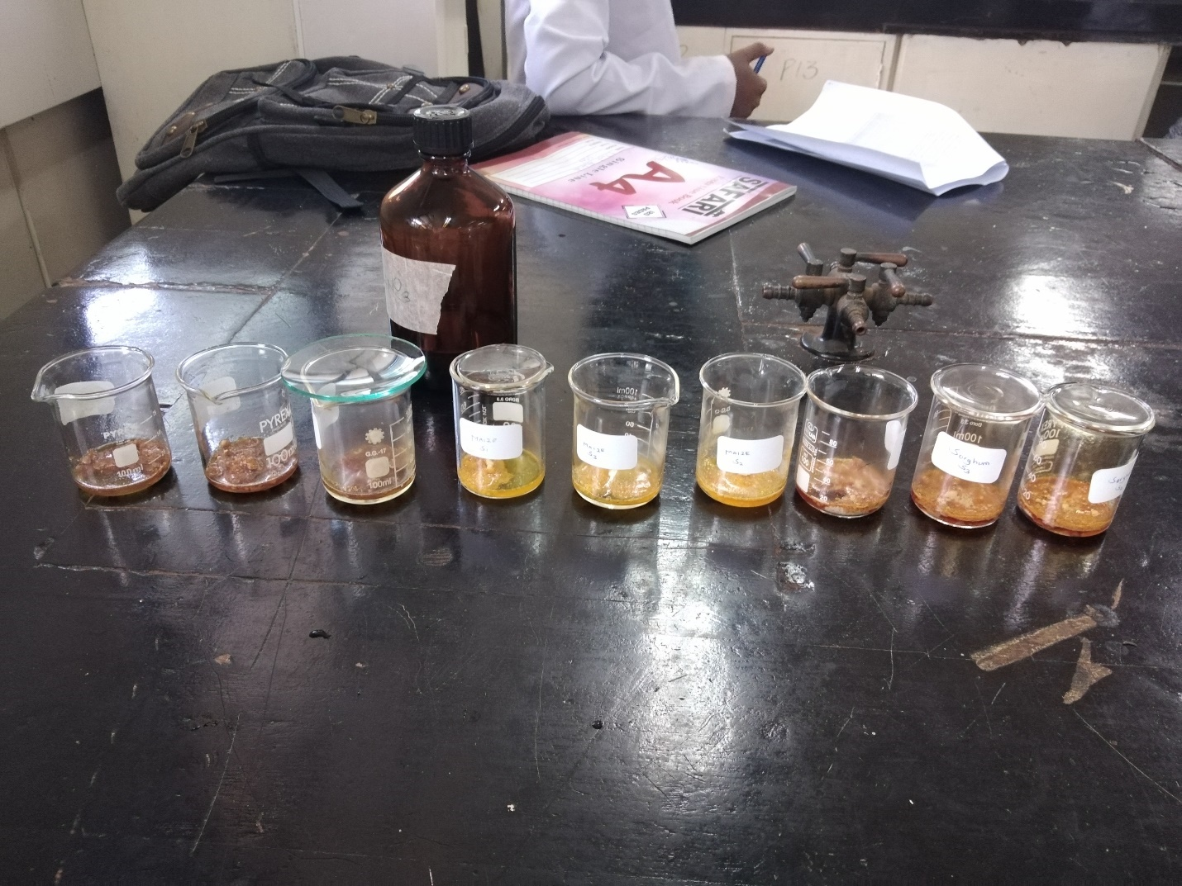
Figure 3.1: Samples digesting using 65% HNO₃.
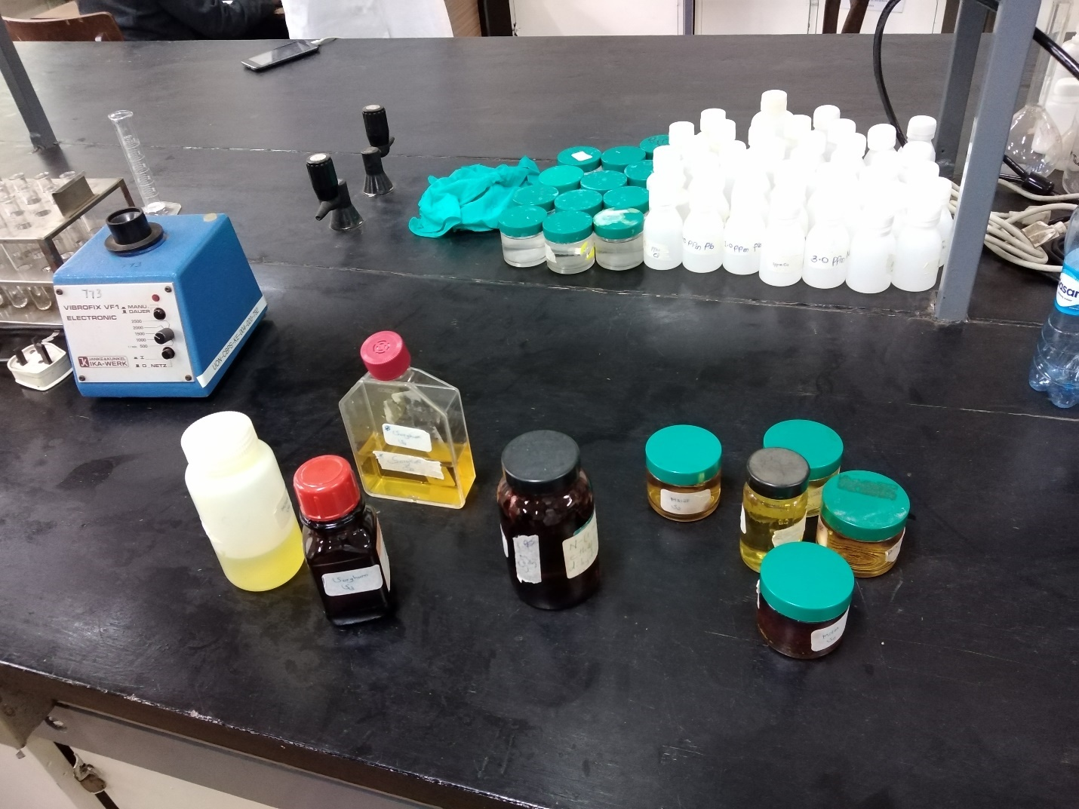

Figure 3.2: Samples ready for analysis

3.5 Data analysis
The mean and standard deviation values of the various sample matrices were computed using Microsoft excel.

CHAPTER 4

RESULTS AND DISCUSSION

4.1 Introduction

The prepared samples were analyzed in the Atomic Absorption Spectrometer together with the standards of the trace elements and the blank solution to determine the presence and the concentration of the six trace (Copper, Nickel, Iron, Magnesium, Manganese and Zinc) elements in maize, millet and sorghum. The obtained concentrations were compared with the levels stipulated by WHO and KEBS. The concentrations were also compared among each other to establish which among the three food grains have a high concentration of the six trace elements.

4.2 Results, Analysis and Discussion

Table 4.1 Concentrations of trace elements in Maize, Millet and Sorghum

Trace elements in maize, millet and sorghum | Concentration (mg/g) | WHO and KEBS (mg/g) (2011)
Zn: Maize  Millet  Sorghum | 0.0206±0.0005  0.0353±0.0162  0.0180±0.0012 | 0.0500-1.5000
Fe: Maize  Millet  Sorghum | 0.0273±0.0060  0.0580±0.0103  0.0675±0.0168 | 0.0200-0.4250
Mg: Maize  Millet  Sorghum | 0.3845±0.0020  0.3852±0.0083  0.3938±0.0015 | 1.0000- 3.0000
Ni: Maize  Millet  Sorghum | 0.0014±0.0000  BDL  BDL | 0.0010-0.0100
Cu: Maize  Millet  Sorghum | 0.0321±0.0060  0.0322±0.0052  0.0434±0.0075 | 0.0250-0.6000
Mn: Maize  Millet  Sorghum | 0.0716±0.0275  0.1391±0.0143  0.2154±0.0181 | 0.0055-0.0500

BDL- Below Detection Limit

4.2.1 Zn

Concentration of Zn levels in maize, millet and sorghum were in the range of 0.0180mg/g -0.0353mg/g. These levels were below the stipulated levels of WHO and KEBS (0.0500mg/g-1.5000mg/g). Amongst the three grains, millet had the highest concentration and sorghum had the lowest concentration as shown in the figure 4.1.

Figure 4.1: Zinc concentration in maize, millet and sorghum.

4.2.2 Iron

The concentrations of Fe in maize, millet and sorghum were 0.0273mg/g, 0.0580mg/g and 0.0675mg/g respectively. The concentrations of Iron in maize, millet and sorghum were within the range stipulated by WHO and KEBS (0.0200mg/g-0.4250mg/g). Sorghum had the highest concentration of Fe while maize had the lowest concentration as shown in the figure 4.2.

Figure 4.2: Fe concentration in maize, millet and sorghum

4.2.3 Magnesium

In this study, Mg concentration in maize, millet and sorghum samples were in the range 0.3845mg/g -0.3938mg/g. These concentrations were way below detection limit stipulated by WHO and KEBS (1.0000mg/g-3.0000mg/g). Figure 4.3 shows that sorghum had the highest concentration of Mg while maize had the lowest concentration of Mg.

Figure 4.3: Mg concentration in maize, millet and sorghum.

4.2.4 Nickel

Nickel was only detected in maize sample with a concentration of 0.0014mg/g while in millet and sorghum it was low to be detected. The concentration of Ni in maize was within the range stipulated by WHO and KEBS(0.0010mg/g-0.0100mg/g). Figure 4.5 shows the concentration of Nickel in maize.

Figure 4.1: Ni concentration in maize, millet and sorghum.

4.2.5 Copper

Copper concentrations in maize, millet and sorghum were in the range 0.0321mg/g, 0.0321mg/g and 0.0434 mg/g. The concentration levels of Cu in maize, millet and sorghum were within the levels stipulated by WHO and KEBS (0.0250mg/g -0.6000mg/g). Sorghum had the highest level of Cu concentration and millet had the lowest level of Cu concentration as shown in figure 4.5.

Figure 4.5: Cu concentration in maize, millet and sorghum.

4.4.6 Manganese

In this research, concentrations of Mn in maize, millet and sorghum were in the range of 0.0716mg/g and 0.2154mg/g. These concentrations were above the levels stipulated WHO and KEBS (0.0055mg/g -0.0500mg/g). As shown in figure 4.6, sorghum had the highest concentration of Mn while maize had the lowest concentration in Mn.

Figure 4.6: Mn concentration in maize, millet and sorghum.

CHAPTER FIVE

CONCLUSION AND RECOMMENDATION

5.1 Conclusion

Among the six trace elements, Mg had the highest concentrations in the milled samples followed by Mn> Fe>Cu>Zn>Ni.
The concentrations of Nickel were only detected in the milled maize grains and was very low in the milled samples of millet and sorghum at the below detection limit of the AAS.
Fe, Ni and Cu had the concentrations within the permissible minimum intake levels as stipulated by WHO and KEBS while Zn and Mn had low concentrations and Mn had very high concentrations.
Among the three milled samples of maize, millet and sorghum, sorghum contained the highest levels of trace elements save for the Zn.

5.2 Recommendation

More research should be on these natural ways of boosting immunity now that the new infections keep emerging now and then due to biological and environmental factors. These researches will enlighten the communities around the world on what to consume for the betterment of one’s health.
Research should be done to determine whether other trace elements in food grains meets the recommended permissible levels stipulated by WHO and KEBS.
The causes of higher levels of Manganese in maize, millet and sorghum should be investigated for appropriate action to be taken and also the cause of very low levels than those set by WHO and KEBS in Zn and Mg.

REFERENCES

Calder, P.C (2013). Feeding the immune system .Proceedings of the Nutrition Society, 72 (3), 299- 309.

Tapiero,H., Townsend, D.A., & Tew, K.D. (2003).Trace elements in human physiology and pathology. Copper. Biomedicine & pharmacotherapy, 57(9), 386- 398.

Soares, A. T. G., da Silva , A. C., Tinkov, A. A., Khan ,H., Santamaria, A., Skalnaya, M.G., & Avila , D. S.(2020). The impact of manganese on neurotransmitter systems. Journal of Trace Elements in Medicine and Biology, 126554.

Bonefeld, Charlotte Menne, Morten Milek Nielsen, Marie T. Vennegaard, Jeanne Duus Johansen, Carsten Geisler, & Jacob P. Thyssen. (2015). “Nickel acts as an adjuvant during cobalt sensitation”. Experimental dermatology, 24(3), pp.229-231.

Al Durtsch (1999). Chromium deficiency diseases and good Nutrition. Nutrition Basic Home . Walton Feed Inc. pp.1-2.

Rink L.,Gabriel P (2000). Zinc and immune system. Proc. Nutr.Soc. 59(4): 541-552.

American Cancer Society (2014). Selenium guide to complementary and alternative methods. Atlanta g.a.pp. 1-5.

WHO and FAO (2002). A manual on nutrition, care and support for people living with HIV/AIDS, Rome. pp. 1-5.

Gitonga, Z., De Groote, H., & Tefera, T. (2015). “Metal silo grain grain storage technology and household food security in Kenya”. Journal of Development and Agricultural Economics, 7(6), 222-23.

Guo, H., Chen, L., Cui, H., Peng, X., Fang, Zuo, Z.,…& Wu, B. (2016). “Research advances on pathways of nickel-induced apoptosis”. International journal of molecular sciences 17 (1), 10.

Aslam, M.F., Majeed, S., Aslam, S.,& Irfan, J. A.(2017). Vitamins: Key role players in boosting up immune response- A mini review. Vitam Miner, 6(1), 2376-1318.

Welch, R. M. (2008). Linkages between trace elements in food crops and human health. Micronutrient deficiencies in global crop production, 287-309.

Chatuvedi, U. C., Shrivastava, R., & Upreti R. K. (2004). Viral infections and trace elements: a complex interaction. Current science, 1536-1554.

Oloo, J. E. O. (2010). Food safety and quality management in Kenya: An overview of the roles played by various stakeholders. African Journal of Food, Agriculture, Nutrition and Development, 10(11).

Khamila, N. S. (2020), Status and Compliance of Flour Fortification by Selected Commercial Maize Mills in Kenya (Doctoral dissertation, JKUAT- Agriculture).

Joint FAO/WHO Expert Committee on Nutrition. Eighth Report. Geneva, World Health Organization, 1971 (WHO Technical Report Series, No. 477).

Worthley, L.I., & Baker, S.B. (2002). The essentials of calcium, magnesium and phosphate metabolism: part I. Physiology. Crucial Care and Resuscitation, 4(4), 301.

Appendices

Table 4.2 Zn in the prepared standards and the samples maize, millet and sorghum.

Samples | Concentration (mg/L) | Absorbance
0.1000 | 0.1027 | 0.0086
0.2000 | 0.1934 | 0.0151
0.3000 | 0.3052 | 0.0231
0.4000 | 0.3987 | 0.0298
Maize S1 | 0.4281 | 0.0319
Maize S2 | 0.4057 | 0.0303
Maize S3 | 0.4043 | 0.0302
Millet S1 | 0.7437 | 0.0545
Millet S2 | 0.6892 | 0.0506
Millet S3 | 0.6865 | 0.0504
Sorghum S1 | 0.3862 | 0.0289
Sorghum S2 | 0.3415 | 0.0257
Sorghum S3 | 0.3499 | 0.0263

Table 4.3 Fe concentration in maize, millet and sorghum
SAMPLES | CONCENTRATION (mg/L) | ABSORBANCE
1.0000 | 1.0268 | 0.0164
2.0000 | 1.9464 | 0.0347
3.0000 | 3.0268 | 0.0562
Maize 1 | 0.4539 | 0.0050
Maize 2 | 0.5042 | 0.0060
Maize 3 | 0.6801 | 0.0095
Millet 1 | 1.3233 | 0.0223
Millet 2 | 1.2278 | 0.0204
Millet 3 | 0.9263 | 0.0144
Sorghum 1 | 1.4690 | 0.0252
Sorghum 2 | 1.5142 | 0.0261
Sorghum 3 | 1.0670 | 0.0172

Table 4.4: Mg concentration in maize, millet and sorghum
Samples | Concentration (mg/L) | Absorbance
0.1000 | 0.1105 | 0.0218
0.2000 | 0.1866 | 0.0418
0.3000 | 0.2954 | 0.0704
0.4000 | 0.4076 | 0.0999
Maize1 | 7.7267 | 2.0241
Maize 2 | 7.6491 | 2.0037
Maize 3 | 7.6963 | 2.0161
Millet 1 | 7.8382 | 2.0534
Millet2 | 7.7587 | 2.0325
Millet 3 | 7.5126 | 1.9678
Sorghum 1 | 7.9104 | 2.0724
Sorghum 2 | 7.8640 | 2.0602
Sorghum 3 | 7.8526 | 2.0572

Table 4.5: Ni concentration in maize, millet and sorghum
Samples | Concentration (mg/L) | Absorbance
0.1000 | 0.1153 | 0.0044
0.2000 | 0.1907 | 0.0059
0.4000 | 0.3666 | 0.0094
0.5000 | 0.5274 | 0.0126
Maize 1 | 0.0198 | 0.0025
Maize 2 | 0.0349 | 0.0028
Maize 3 | -0.0153 | 0.0018
Millet 1 | -0.0706 | 0.0007
Millet 2 | -0.0907 | 0.0003
Millet 3 | -0.1058 | 0.0000
Sorghum 1 | -0.0606 | 0.0009
Sorghum 2 | -0.0354 | 0.0014
Sorghum 3 | -0.0555 | 0.0010

Table 4.6: Cu concentration in maize, millet and sorghum

Samples | Concentration (mg/L) | Absorbance
0.5000 | 0.3646 | 0.0009
1.0000 | 1.3021 | 0.0027
1.5000 | 1.3021 | 0.0027
2.0000 | 2.0312 | 0.0041
Maize1 | 0.7812 | 0.0017
Maize 2 | 0.5729 | 0.0013
Maize 3 | 0.5729 | 0.0013
Millet1 | 0.6250 | 0.0014
Millet 2 | 0.5208 | 0.0012
Miller 3 | 0.7292 | 0.0016
Sorghum 1 | 0.7812 | 0.0017
Sorghum 2 | 1.0417 | 0.0022
Sorghum 3 | 0.7812 | 0.0017

Table 4.7: Mn concentration in maize, millet and sorghum

Samples | Concentration (mg/L) | Absorbance
1.0000 | 1.0234 | -0.0046
2.0000 | 1.9649 | -$0.0023$.0023
3.0000 | 2.3333 | -$0.0014$.0014
4.0000 | 4.0117 | 0.0027
Maize 1 | 0.9825 | -$0.0047$.0047
Maize 2 | 1.2690 | -0.0040
Maize 3 | 2.0468 | -0.0021
Millet 1 | 2.6608 | -0.0006
Millet 2 | 2.5789 | -0.0008
Millet 3 | 3.1111 | 0.0005
Sorghum 1 | 4.0017 | 0.0027
Sorghum 2 | 4.2164 | 0.0032
Sorghum 3 | 4.7076 | 0.0044

